VISVESVARAYA TECHNOLOGICAL UNIVERSITY
“JnanaSangama”, Belgaum -590014, Karnataka.



LAB REPORT
on

OPERATING SYSTEMS

Submitted by

WAGISHA KUMAR (1BF24CS334)

in partial fulfillment for the award of the degree of

BACHELOR OF ENGINEERING
in
COMPUTER SCIENCE AND ENGINEERING


B.M.S. COLLEGE OF ENGINEERING
(Autonomous Institution under VTU)
BENGALURU-560019
Feb-2026 to June-2026

B. M. S. College of Engineering,
Bull Temple Road, Bangalore 560019
(Affiliated To Visvesvaraya Technological University, Belgaum)
Department of Computer Science and Engineering


CERTIFICATE
This is to certify that the Lab work entitled “OPERATING SYSTEMS – 23CS4PCOPS” carried out by Wagisha Kumar(1BF24CS334), who is Bonafide student of B. M. S. College of Engineering. It is in partial fulfilment for the award of Bachelor of Engineering in Computer Science and Engineering of the Visvesvaraya Technological University, Belgaum during the year Feb-2026 to June-2026. The Lab report has been approved as it satisfies the academic requirements in respect of a OPERATING SYSTEMS - (23CS4PCOPS) work prescribed for the said degree.

Faculty Incharge Name Dr. Kavitha Sooda
Assistant Professor Professor and Head
Department of CSE Department of CSE
BMSCE, Bengaluru BMSCE, Bengaluru

Index Sheet
Sl.  No. | Experiment Title | Page No.
1. | Write a C program to simulate the following non-pre-emptive CPU scheduling algorithm to find turnaround time and waiting time.  →FCFS  → SJF (pre-emptive & Non-preemptive)  → Priority (pre-emptive & Non-pre-emptive)  →Round Robin | 1-18
2. | Write a C program to simulate multi-level queue scheduling algorithm considering the following scenario. All the processes in the system are divided into two categories – system processes and user processes. System processes are to be given higher priority than user processes. Use FCFS scheduling for the processes in each queue. | 19-21
3. | Write a C program to simulate Real-Time CPU Scheduling algorithms:  - Rate- Monotonic  - Earliest-deadline First  - Proportional scheduling | 22-30
4. | Write a C program to simulate:  a) Producer-Consumer problem using semaphores.  b) Dining-Philosopher’s problem | 31-36
5. | Write a C program to simulate.  a) Bankers’ algorithm for the purpose of deadlock avoidance.  b) Deadlock Detection | 37-43
6. | Write a C program to simulate the following contiguous memory allocation techniques.  a) Worst-fit  b) Best-fit  c) First-fit | 44-49
7. | Write a C program to simulate page replacement algorithms.  a) FIFO  b) LRU  c) Optimal | 50-54

Course Outcomes
C01 | Apply the different concepts and functionalities of Operating System
C02 | Analyse various Operating system strategies and techniques
C03 | Demonstrate the different functionalities of Operating System.
C04 | Conduct practical experiments to implement the functionalities of Operating system.

Program -1
Question:
Write a C program to simulate the following non-pre-emptive CPU scheduling algorithm to find turnaround time and waiting time.
→FCFS
→ SJF (pre-emptive & Non-preemptive)
→ Priority (pre-emptive & Non-pre-emptive)
→Round Robin (Experiment with different quantum sizes for RR algorithm)

Code:
=>FCFS:
#include <stdio.h>

struct Process {
int pid; // Process ID
int bt; // Burst Time
int at; // Arrival Time
int wt; // Waiting Time
int tat; // Turnaround Time
int ct; // Completion Time
};

int main() {
int n;
printf("Enter number of processes: ");
scanf("%d", &n);

struct Process p[n];

// Input burst time and arrival time
for (int i = 0; i < n; i++) {
p[i].pid = i + 1;
printf("Enter Burst Time and Arrival Time for Process %d: ", p[i].pid);
scanf("%d %d", &p[i].bt, &p[i].at);
}

// Sort processes by arrival time (FCFS rule)
for (int i = 0; i < n - 1; i++) {
for (int j = i + 1; j < n; j++) {
if (p[i].at > p[j].at) {
struct Process temp = p[i];
p[i] = p[j];
p[j] = temp;
}
}
}

// Calculate Completion, Turnaround, and Waiting Times
int time = 0;
for (int i = 0; i < n; i++) {
if (time < p[i].at) {
time = p[i].at; // CPU waits if process hasn't arrived
}
time += p[i].bt;
p[i].ct = time;
p[i].tat = p[i].ct - p[i].at;
p[i].wt = p[i].tat - p[i].bt;
}

// Display results
printf("\nProcess\tAT\tBT\tCT\tTAT\tWT\n");
for (int i = 0; i < n; i++) {
printf("P%d\t%d\t%d\t%d\t%d\t%d\n",
p[i].pid, p[i].at, p[i].bt, p[i].ct, p[i].tat, p[i].wt);
}

// Calculate average TAT and WT
float avg_tat = 0, avg_wt = 0;
for (int i = 0; i < n; i++) {
avg_tat += p[i].tat;
avg_wt += p[i].wt;
}
avg_tat /= n;
avg_wt /= n;

printf("\nAverage Turnaround Time = %.2f", avg_tat);
printf("\nAverage Waiting Time = %.2f\n", avg_wt);

return 0;
}

Result:
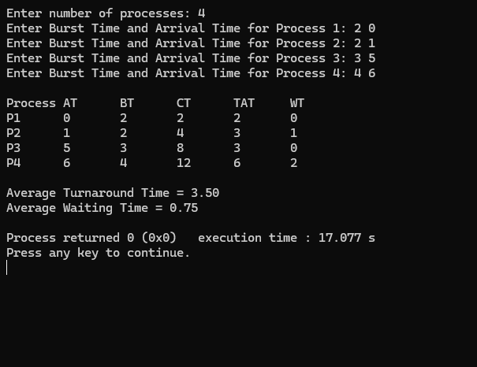

=>SJF(Non-preemptive):
#include <stdio.h>
struct Process {
int pid;
int at; // Arrival Time
int bt; // Burst Time
int ct; // Completion Time
int tat; // Turnaround Time
int wt; // Waiting Time
int finished;
};
int main() {
int n, i, current_time = 0, completed = 0, shortest;
printf("Enter number of processes: ");
scanf("%d", &n);
struct Process p[n];
// Input
for(i = 0; i < n; i++) {
p[i].pid = i + 1;
p[i].finished = 0;

printf("Enter Arrival Time for P%d: ", p[i].pid);
scanf("%d", &p[i].at);

printf("Enter Burst Time for P%d: ", p[i].pid);
scanf("%d", &p[i].bt);
}

// SJF Scheduling
while(completed < n) {

shortest = -1;
for(i = 0; i < n; i++) {
if(p[i].at <= current_time && p[i].finished == 0) {

if(shortest == -1 || p[i].bt < p[shortest].bt) {
shortest = i;
}
}
}
if(shortest == -1) {
current_time++;
}
else {
p[shortest].ct = current_time + p[shortest].bt;
p[shortest].tat = p[shortest].ct - p[shortest].at;
p[shortest].wt = p[shortest].tat - p[shortest].bt;
current_time = p[shortest].ct;
p[shortest].finished = 1;
completed++;
}
}
// Output
printf("\nPID\tAT\tBT\tCT\tTAT\tWT\n");

for(i = 0; i < n; i++) {
printf("P%d\t%d\t%d\t%d\t%d\t%d\n",
p[i].pid, p[i].at, p[i].bt, p[i].ct, p[i].tat, p[i].wt);
}
return 0;
}

Result:
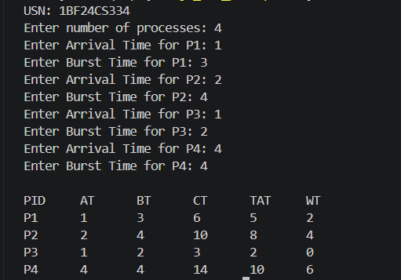

=>SJF(Preemptive):
#include <stdio.h>

struct Process {
int pid;
int at; // Arrival Time
int bt; // Burst Time
int rt; // Remaining Time
int ct; // Completion Time
int tat; // Turnaround Time
int wt; // Waiting Time
};

int main() {

int n, i, current_time = 0, completed = 0, shortest;

printf("Enter number of processes: ");
scanf("%d", &n);

struct Process p[n];

// Input
for(i = 0; i < n; i++) {
p[i].pid = i + 1;

printf("Enter Arrival Time and Burst Time for Process %d: ", p[i].pid);
scanf("%d %d", &p[i].at, &p[i].bt);

p[i].rt = p[i].bt; // Remaining time initially equals burst time
}

// SJF Preemptive Scheduling
while(completed < n) {

shortest = -1;

for(i = 0; i < n; i++) {
if(p[i].at <= current_time && p[i].rt > 0) {

if(shortest == -1 || p[i].rt < p[shortest].rt) {
shortest = i;
}
}
}

if(shortest == -1) {
current_time++;
}
else {
// Execute for 1 unit time
p[shortest].rt--;

current_time++;

// If process finishes
if(p[shortest].rt == 0) {

completed++;

p[shortest].ct = current_time;

p[shortest].tat = p[shortest].ct - p[shortest].at;

p[shortest].wt = p[shortest].tat - p[shortest].bt;
}
}
}
// Output
printf("\nPID\tAT\tBT\tCT\tTAT\tWT\n");

for(i = 0; i < n; i++) {
printf("P%d\t%d\t%d\t%d\t%d\t%d\n",
p[i].pid, p[i].at, p[i].bt, p[i].ct, p[i].tat, p[i].wt);
}
float avg_tat = 0, avg_wt = 0;
for(i = 0; i < n; i++) {
avg_tat += p[i].tat;
avg_wt += p[i].wt;
}
avg_tat /= n;
avg_wt /= n;
printf("\nAverage Turnaround Time = %.2f", avg_tat);
printf("\nAverage Waiting Time = %.2f\n", avg_wt);
return 0;
}
Result:
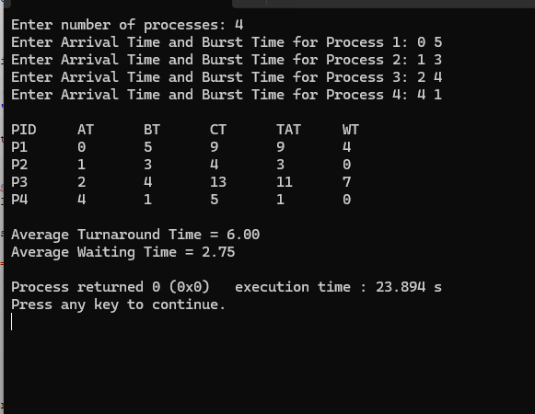

=>Priority(Preemptive):

#include <stdio.h>

int main() {
int n;
printf("Enter number of processes: ");
scanf("%d", &n);

int pid[n], at[n], bt[n], pr[n];
int ct[n], tat[n], wt[n], rt[n];

int current_time = 0, completed = 0;

for(int i = 0; i < n; i++) {
printf("\nEnter Process ID: ");
scanf("%d", &pid[i]);

printf("Enter Arrival Time: ");
scanf("%d", &at[i]);

printf("Enter Burst Time: ");
scanf("%d", &bt[i]);

printf("Enter Priority (smaller number = higher priority): ");
scanf("%d", &pr[i]);

rt[i] = bt[i]; // remaining time initially = burst time
}
while(completed < n) {
int highest_priority = 9999;
int selected = -1;
for(int i = 0; i < n; i++) {
if(at[i] <= current_time && rt[i] > 0) {
if(pr[i] < highest_priority) {
highest_priority = pr[i];
selected = i;
}
}
}
if(selected == -1) {
current_time++;
}
else {
rt[selected]--; // execute for 1 unit
current_time++;
if(rt[selected] == 0) {
completed++;

ct[selected] = current_time;
tat[selected] = ct[selected] - at[selected];
wt[selected] = tat[selected] - bt[selected];
}
}
}
float avg_wt = 0, avg_tat = 0;
printf("\nPID\tAT\tBT\tPR\tCT\tTAT\tWT\n");
for(int i = 0; i < n; i++) {
printf("%d\t%d\t%d\t%d\t%d\t%d\t%d\n",
pid[i], at[i], bt[i], pr[i], ct[i], tat[i], wt[i]);
avg_wt += wt[i];
avg_tat += tat[i];
}
avg_wt /= n;
avg_tat /= n;
printf("\nAverage Waiting Time = %.2f", avg_wt);
printf("\nAverage Turnaround Time = %.2f", avg_tat);
return 0;
}
Result:
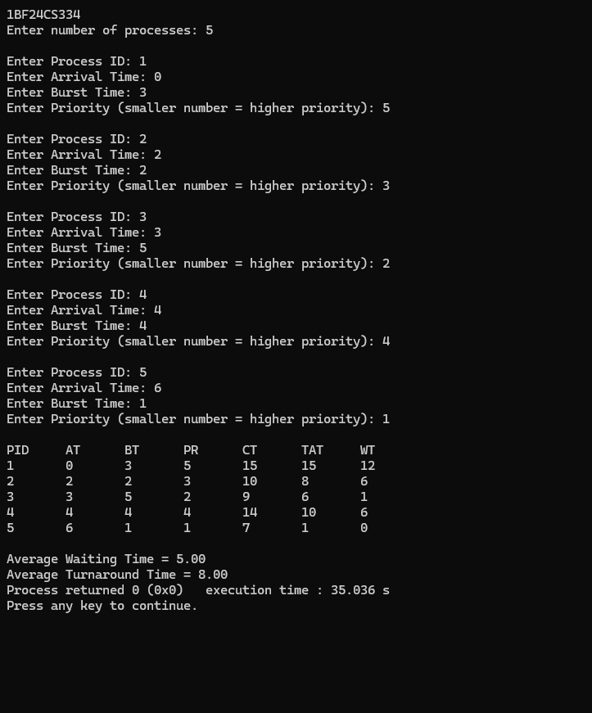
=>Priority(Non-Preemptive):
#include <stdio.h>
int main() {
int n;
printf("Enter number of processes: ");
scanf("%d", &n);

int pid[n], at[n], bt[n], pr[n];
int ct[n], tat[n], wt[n];
int completed[n];

int current_time = 0, completed_count = 0;

for(int i = 0; i < n; i++) {
printf("\nEnter Process ID: ");
scanf("%d", &pid[i]);

printf("Enter Arrival Time: ");
scanf("%d", &at[i]);

printf("Enter Burst Time: ");
scanf("%d", &bt[i]);

printf("Enter Priority (smaller number = higher priority): ");
scanf("%d", &pr[i]);

completed[i] = 0;
}

while(completed_count < n) {
int highest_priority = 9999;
int selected = -1;

for(int i = 0; i < n; i++) {
if(at[i] <= current_time && completed[i] == 0) {
if(pr[i] < highest_priority) {
highest_priority = pr[i];
selected = i;
}
}
}

if(selected == -1) {
current_time++;
}
else {
ct[selected] = current_time + bt[selected];
tat[selected] = ct[selected] - at[selected];
wt[selected] = tat[selected] - bt[selected];

current_time = ct[selected];

completed[selected] = 1;
completed_count++;
}
}
float avg_wt = 0, avg_tat = 0;
printf("\nPID\tAT\tBT\tPR\tCT\tTAT\tWT\n");
for(int i = 0; i < n; i++) {
printf("%d\t%d\t%d\t%d\t%d\t%d\t%d\n",
pid[i], at[i], bt[i], pr[i], ct[i], tat[i], wt[i]);
avg_wt += wt[i];
avg_tat += tat[i];
}
avg_wt = avg_wt / n;
avg_tat = avg_tat / n;
printf("\nAverage Waiting Time = %.2f", avg_wt);
printf("\nAverage Turnaround Time = %.2f", avg_tat);
return 0;
}
Result:
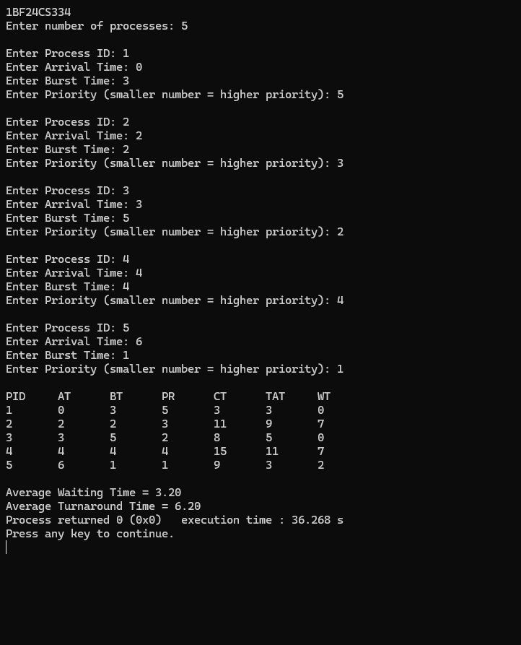
=>Round Robin:

#include <stdio.h>
int main() {
int n, tq;
printf("USN:1BF24CS334\n");
printf("Enter number of processes: ");
scanf("%d", &n);

printf("Enter Time Quantum: ");
scanf("%d", &tq);

int at[n], bt[n], rt[n], ct[n], tat[n], wt[n], rt_resp[n];
int queue[100], front = 0, rear = 0;
int visited[n];

printf("Enter arrival times:\n");
for(int i = 0; i < n; i++)
scanf("%d", &at[i]);

printf("Enter burst times:\n");
for(int i = 0; i < n; i++) {
scanf("%d", &bt[i]);
rt[i] = bt[i];
visited[i] = 0;
rt_resp[i] = -1;
}

int current_time = 0, completed = 0;

queue[rear++] = 0;
visited[0] = 1;

while(front < rear) {

int i = queue[front++];

if(rt_resp[i] == -1)
rt_resp[i] = current_time - at[i];

if(rt[i] > tq) {
current_time += tq;
rt[i] -= tq;
}
else {
current_time += rt[i];
rt[i] = 0;

ct[i] = current_time;
tat[i] = ct[i] - at[i];
wt[i] = tat[i] - bt[i];

completed++;
}

for(int j = 0; j < n; j++) {
if(at[j] <= current_time && visited[j] == 0) {
queue[rear++] = j;
visited[j] = 1;
}
}

if(rt[i] > 0)
queue[rear++] = i;

if(front == rear) {
for(int j = 0; j < n; j++) {
if(rt[j] > 0) {
queue[rear++] = j;
visited[j] = 1;
break;
}
}
}
}

float avg_wt = 0, avg_tat = 0;

printf("\nRRS scheduling:\n");
printf("PID\tAT\tBT\tCT\tTAT\tWT\tRT\n");

for(int i = 0; i < n; i++) {
printf("%d\t%d\t%d\t%d\t%d\t%d\t%d\n",
i+1, at[i], bt[i], ct[i], tat[i], wt[i], rt_resp[i]);
avg_wt += wt[i];
avg_tat += tat[i];
}
printf("\nAverage turnaround time: %.6fms\n", avg_tat/n);
printf("Average waiting time: %.6fms\n", avg_wt/n);
return 0;
}

Result:
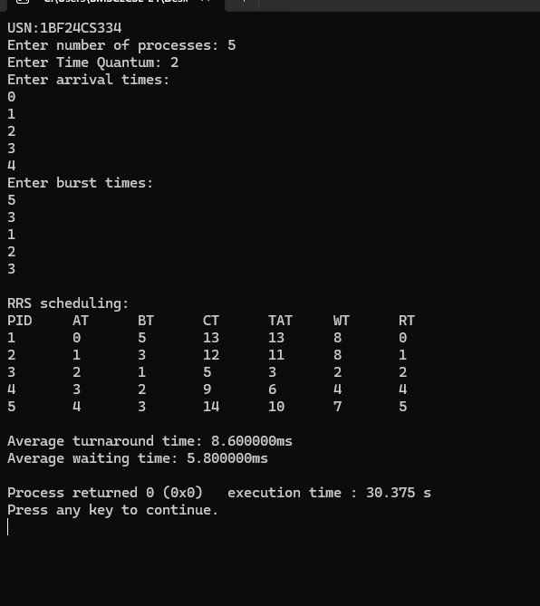

Program -2
Question:
Write a C program to simulate multi-level queue scheduling algorithm considering the following scenario. All the processes in the system are divided into two categories – system processes and user processes. System processes are to be given higher priority than user processes. Use FCFS scheduling for the processes in each queue.

#include <stdio.h>

#define MAX 10

typedef struct {
int pid, at, bt, ct, tat, wt, q, done;
} P;

P p[MAX];

int main() {

int n;
int time = 0, completed = 0;
float avg_tat = 0, avg_wt = 0;

printf("Enter number of processes: ");
scanf("%d", &n);

// Input
for(int i = 0; i < n; i++) {

p[i].pid = i + 1;

printf("Enter AT BT Queue(1-System / 2-User) for P%d: ", i + 1);

scanf("%d%d%d", &p[i].at, &p[i].bt, &p[i].q);

p[i].done = 0;
}

// Scheduling
while(completed < n) {

int idx = -1;

// First search Queue 1 (Higher Priority)
for(int i = 0; i < n; i++) {

if(p[i].done == 0 && p[i].at <= time && p[i].q == 1) {

if(idx == -1 || p[i].at < p[idx].at)
idx = i;
}
}

// If no system process, search Queue 2
if(idx == -1) {

for(int i = 0; i < n; i++) {

if(p[i].done == 0 && p[i].at <= time && p[i].q == 2) {

if(idx == -1 || p[i].at < p[idx].at)
idx = i;
}
}
}

// Execute process
if(idx != -1) {

time += p[idx].bt;

p[idx].ct = time;

p[idx].tat = p[idx].ct - p[idx].at;

p[idx].wt = p[idx].tat - p[idx].bt;

avg_tat += p[idx].tat;
avg_wt += p[idx].wt;

p[idx].done = 1;

completed++;
}

else {
time++;
}
}

// Output
printf("\nPID\tQ\tAT\tBT\tCT\tTAT\tWT\n");

for(int i = 0; i < n; i++) {
printf("P%d\t%d\t%d\t%d\t%d\t%d\t%d\n",

p[i].pid,
p[i].q,
p[i].at,
p[i].bt,
p[i].ct,
p[i].tat,
p[i].wt);
}
printf("\nAverage TAT = %.2f", avg_tat / n);
printf("\nAverage WT = %.2f\n", avg_wt / n);
return 0;
}

Result:
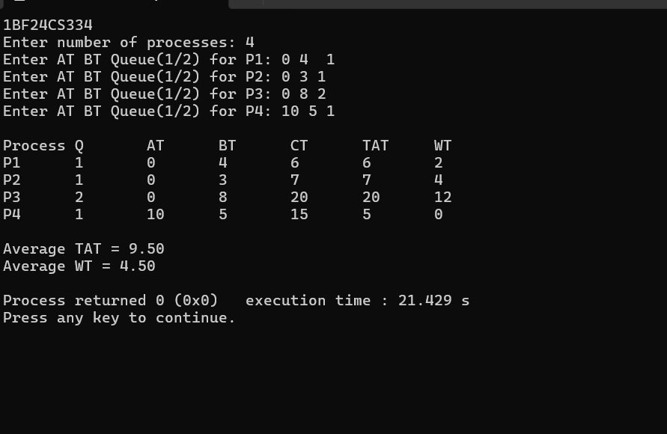

Program -3
Question:
Write a C program to simulate Real-Time CPU Scheduling algorithms:
a)Rate- Monotonic
b)Earliest-deadline First
c)Proportional scheduling

=>Rate- Monotonic

#include <stdio.h>
#include <math.h>
#define MAX 1
// Function to find GCD
int gcd(int a, int b) {
while (b != 0) {
int t = b;
b = a % b;
a = t;
}
return a;
}
// Function to find LCM of two numbers
int lcm(int a, int b) {
return (a * b) / gcd(a, b);
}
// Function to find LCM of all periods
int find_lcm(int arr[], int n) {
int res = arr[0];
for (int i = 1; i < n; i++) {
res = lcm(res, arr[i]);
}
return res;
}
int main() {
int n, burst[MAX], period[MAX];
int remaining[MAX] = {0};
float utilization = 0;
printf("usn:1BF24CS334\n");

printf("Enter the number of processes:");
scanf("%d", &n);

printf("Enter the CPU burst times:\n");
for (int i = 0; i < n; i++) {
scanf("%d", &burst[i]);
}

printf("Enter the time periods:\n");
for (int i = 0; i < n; i++) {
scanf("%d", &period[i]);
}
// Calculate LCM (hyperperiod)
int hyper = find_lcm(period, n);
printf("LCM=%d\n\n", hyper);

// Display task table
printf("Rate Monotone Scheduling:\n");
printf("ID\tBurst\tPeriod\n");
for (int i = 0; i < n; i++) {
printf("%d\t%d\t%d\n", i + 1, burst[i], period[i]);
utilization += (float)burst[i] / period[i];
}

// RMS Utilization Bound
float bound = n * (pow(2, 1.0 / n) - 1);

printf("\n%f <= %f =>%s\n", utilization, bound,
(utilization <= bound) ? "true" : "false");

printf("Scheduling occurs for %d ms\n\n", hyper);

int last = -2; // to track context switch

// RMS Scheduling Simulation
for (int t = 0; t < hyper; t++) {
// Release tasks
for (int i = 0; i < n; i++) {
if (t % period[i] == 0) {
remaining[i] = burst[i];
}
}

int selected = -1;
// Select highest priority (smallest period)
for (int i = 0; i < n; i++) {
if (remaining[i] > 0) {
if (selected == -1 || period[i] < period[selected]) {
selected = i;
}
}
}
// Print only when task changes
if (selected != last) {
if (selected != -1)
printf("%dms onwards: Process %d running\n", t, selected + 1);
else
printf("%dms onwards: CPU is idle\n", t);
last = selected;
}
// Execute selected task
if (selected != -1) {
remaining[selected]--;
}
}
return 0;
}
Result:
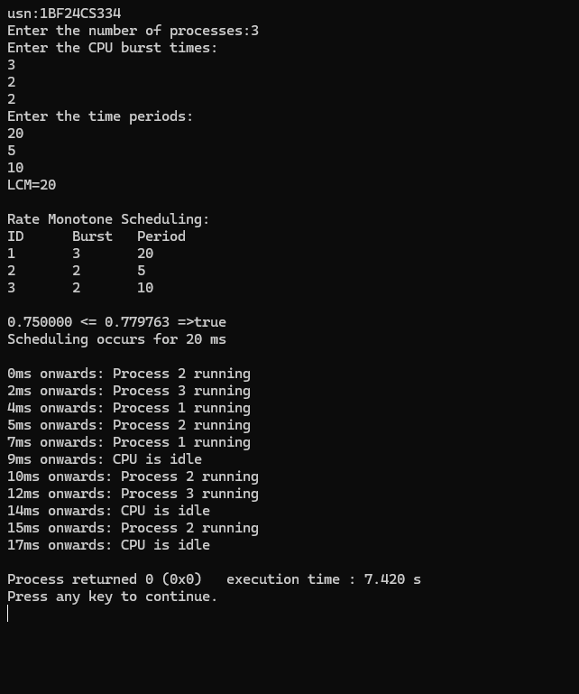
=> Earliest-deadline First

#include <stdio.h>
#define MAX 10
typedef struct {
int pid;
int bt; // Burst Time
int dl; // Deadline
int ct; // Completion Time
int tat; // Turnaround Time
int wt; // Waiting Time
int done;
} Process;
int main() {
Process p[MAX];
int n;
printf("Enter number of processes: ");
scanf("%d", &n);
// Input
for(int i = 0; i < n; i++) {
p[i].pid = i + 1;
printf("Enter Burst Time and Deadline for P%d: ", i + 1);
scanf("%d%d", &p[i].bt, &p[i].dl);
p[i].done = 0;
}
int completed = 0;
int time = 0;
float avg_tat = 0, avg_wt = 0;

// EDF Scheduling
while(completed < n) {
int idx = -1;
// Select process with earliest deadline
for(int i = 0; i < n; i++) {
if(p[i].done == 0) {
if(idx == -1 || p[i].dl < p[idx].dl)
idx = i;
}
}
// Execute selected process
time += p[idx].bt;
p[idx].ct = time;
p[idx].tat = p[idx].ct;
p[idx].wt = p[idx].tat - p[idx].bt;
avg_tat += p[idx].tat;
avg_wt += p[idx].wt;
p[idx].done = 1;
completed++;
}
// Output
printf("\nPID\tBT\tDL\tCT\tTAT\tWT\n");

for(int i = 0; i < n; i++) {

printf("P%d\t%d\t%d\t%d\t%d\t%d\n",
p[i].pid,
p[i].bt,
p[i].dl,
p[i].ct,
p[i].tat,
p[i].wt);
}
printf("\nAverage TAT = %.2f", avg_tat / n);
printf("\nAverage WT = %.2f\n", avg_wt / n);
return 0;
}
Result:
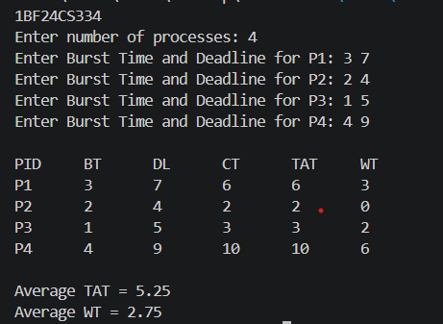

=>Proportional scheduling:
#include<stdio.h>
#include <stdlib.h>
#include <time.h>
typedef struct
{
char name[5]; int tickets; }
Process;
int main() {
int n, total_tickets = 0; float total_T =0.0;
printf("USN: 1BF24CS334\n");
printf("Enter the number of Processes: ");
scanf("%d", &n);
Process p[n];
srand(time(NULL));
for (int i = 0; i < n; i++)
{ printf("\nProcess %d:\n", i + 1);
sprintf(p[i].name, "P%d", i + 1);
printf("Tickets: ");
scanf("%d", &p[i].tickets);
total_tickets += p[i].tickets;
total_T +=p[i].tickets;
}
printf("\n--- Proportional Share Scheduling ---\n");
printf("Enter the Time Period for scheduling: ");
int m;

scanf("%d",&m);
for (int i = 0; i < m; i++)
{
int winning_ticket = rand() % total_tickets + 1;
int accumulated_tickets = 0;
int winner_index;
for (int j = 0; j < n; j++)
{
accumulated_tickets += p[j].tickets;
if (winning_ticket <= accumulated_tickets)
{
winner_index = j; break;
}
}
printf("Tickets picked: %d, Winner: %s\n", winning_ticket,
p[winner_index].name);
}
for (int i = 0; i < n; i++)
{
printf("\nThe Process: %s gets %0.2f%% of Processor Time.\n", p[i].name,
((p[i].tickets / total_T) * 100));
} return 0; }

Result:
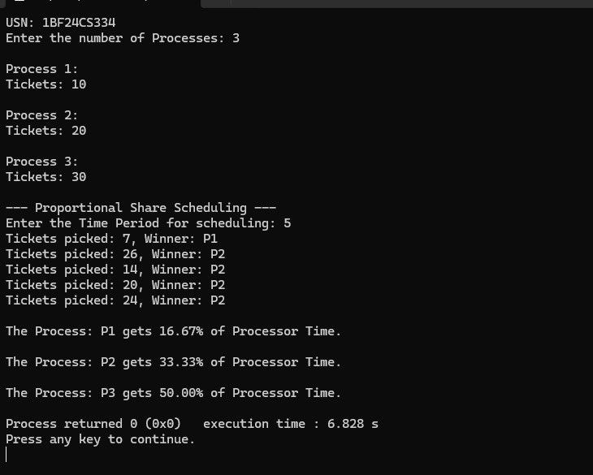

Program -4
Question:
Write a C program to simulate:
a) Producer-Consumer problem using semaphores.
b) Dining-Philosopher’s problem.
=> Producer-Consumer problem using semaphores
#include <stdio.h>
#include <stdlib.h>
#define BUFFER_SIZE 5
int buffer[BUFFER_SIZE];
int in = 0;
int out = 0;

int empty = BUFFER_SIZE;
int full = 0;

void produce() {
if (empty == 0) {
printf("\nBuffer is full! Cannot produce.\n");
return;
}
int item;
printf("Enter item to produce: ");
scanf("%d", &item);
buffer[in] = item;
printf("Produced: %d at index %d\n", item, in);
in = (in + 1) % BUFFER_SIZE;
empty--;
full++;
}

void consume() {
if (full == 0) {
printf("\nBuffer is empty! Cannot consume.\n");
return;
}

int item = buffer[out];
printf("Consumed: %d from index %d\n", item, out);

out = (out + 1) % BUFFER_SIZE;
full--;
empty++;
}

int main() {
int choice;
printf("Usn: 1BF24CS334\n");
printf("Buffer Size: %d\n", BUFFER_SIZE);

while (1) {
printf("\n1. Produce\n2. Consume\n3. Exit\n");
printf("Current State: [Full slots: %d | Empty slots: %d]\n", full, empty);
printf("Enter choice: ");
if (scanf("%d", &choice) != 1) break;
switch (choice) {
case 1:
produce();
break;
case 2:
consume();
break;
case 3:
printf("Exiting...\n");
exit(0);
default:
printf("Invalid choice!\n");
}}
return 0;
}Result: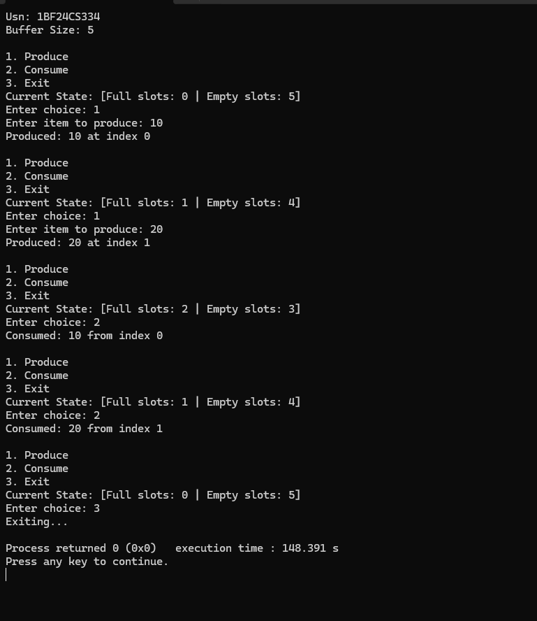
=>Dining Philosophers problem.

#include<stdio.h>
#include<pthread.h>
#include<unistd.h>
#define N 5 // Number of philosophers
pthread_mutex_t forks[N]; // One mutex per fork
pthread_t philosophers[N];
void* philosopher(void* num)
{
int id = *(int*)num;
int left = id; // left fork index
int right = (id + 1) % N; // right fork index
while (1)
{
printf("Philosopher %d is thinking.\n", id);
sleep(1); // Thinking
// To avoid deadlock, philosophers with even id pick left then right,
// odd id pick right then left.
if (id % 2 == 0)
{
// Pick up left fork
pthread_mutex_lock(&forks[left]);
printf("Philosopher %d picked up left fork %d.\n", id, left);
// Pick up right fork

pthread_mutex_lock(&forks[right]);
printf("Philosopher %d picked up right fork %d.\n", id, right); }
else
{ // Pick up right fork
pthread_mutex_lock(&forks[right]);
printf("Philosopher %d picked up right fork %d.\n", id, right); // Pick up left
fork pthread_mutex_lock(&forks[left]);
printf("Philosopher %d picked up left fork %d.\n", id, left);
}
// Eating
printf("Philosopher %d is eating.\n", id);
sleep(2); // Put down forks
pthread_mutex_unlock(&forks[left]);
pthread_mutex_unlock(&forks[right]);
printf("Philosopher %d put down forks %d and %d.\n", id, left, right);
}
return NULL;
}

int main() {
int i;
int ids[N]; // Initialize forks (mutexes)
for (i = 0; i < N; i++)
{ pthread_mutex_init(&forks[i], NULL);
ids[i] = i;
}
// Create philosopher threads
for (i = 0; i < N; i++)

{
pthread_create(&philosophers[i], NULL, philosopher, &ids[i]);
} // Join threads (will never happen here, but good practice)
for (i = 0; i < N; i++)
{
pthread_join(philosophers[i], NULL); }
// Destroy mutexes (unreachable here)
for (i = 0; i < N; i++)
{
pthread_mutex_destroy(&forks[i]);
}
return 0;
}

Result:
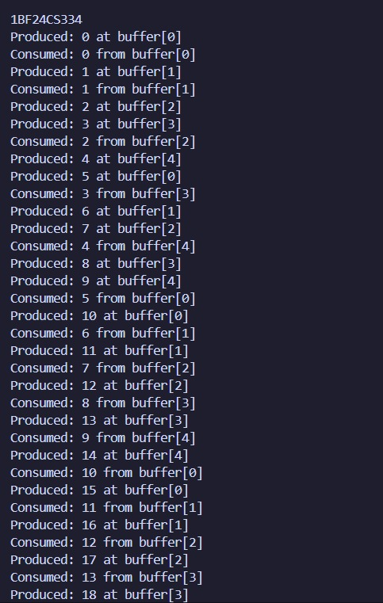

Program -5
Question:
Write a C program to simulate.
a) Bankers’ algorithm for the purpose of deadlock avoidance.
b) Deadlock Detection

=>Bankers algorithm deadlock avoidance:
#include<stdio.h>
int main()
{
int allocation[10][10], request[10][10];
int available[10];
int finish[10], safeSequence[10];
int i, j, k, p, r, count = 0;
printf("Enter the number of processes: ");
scanf("%d", &p);
printf("Enter the number of resources: ");
scanf("%d", &r)
// Allocation Matrix
printf("Enter the allocation matrix:\n");
for(i = 0; i < p; i++)
{
printf("Process %d: ", i);
for(j = 0; j < r; j++)
{
scanf("%d", &allocation[i][j]);
}
}
// Request Matrix
printf("Enter the request matrix:\n");
for(i = 0; i < p; i++)
{
printf("Process %d: ", i);
for(j = 0; j < r; j++)
{
scanf("%d", &request[i][j]);
}
}
// Available Resources
printf("Enter the available resources: ");
for(i = 0; i < r; i++)
{
scanf("%d", &available[i]);
}
// Initialize finish array
for(i = 0; i < p; i++)
{
finish[i] = 0;
}
while(count < p)
{
int found = 0;
for(i = 0; i < p; i++)
{
if(finish[i] == 0)
{
for(j = 0; j < r; j++)
{
if(request[i][j] > available[j])
{
break;
}
}
if(j == r)
{
for(k = 0; k < r; k++)
{
available[k] += allocation[i][k];
}

safeSequence[count++] = i;
finish[i] = 1;
found = 1;
}
}
}
if(found == 0)
{
break;
}
}
if(count == p)
{
printf("\nSystem is in safe state.\n");
printf("Safe Sequence is: ");
for(i = 0; i < p; i++)
{
printf("P%d ", safeSequence[i]);
}
}
else{
printf("\nDeadlock detected in the system.\n");
}
return 0;
}

Result:
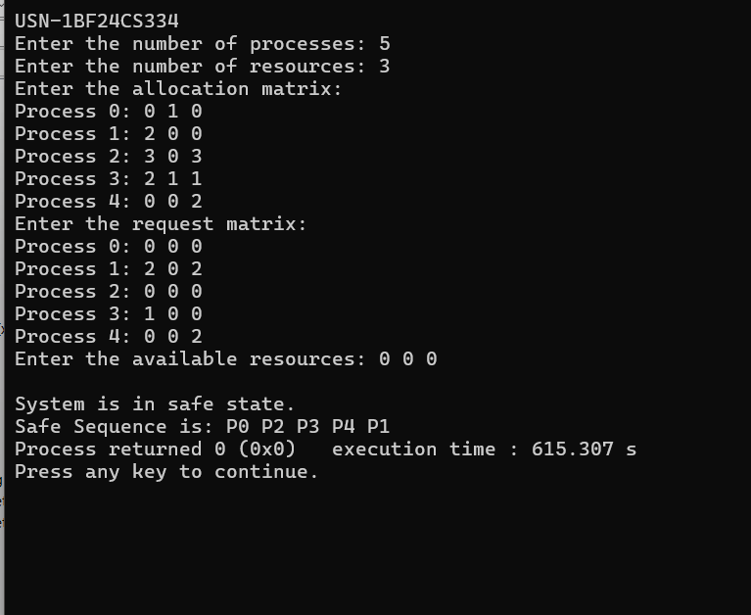

- Deadlock Detection:

#include<stdio.h>

int main()
{
int allocation[10][10], request[10][10];
int available[10];
int finish[10], safeSequence[10];
int i, j, k, p, r, count = 0;

printf("Enter the number of processes: ");
scanf("%d", &p);

printf("Enter the number of resources: ");
scanf("%d", &r);

// Allocation Matrix
printf("Enter the allocation matrix:\n");
for(i = 0; i < p; i++)
{
printf("Process %d: ", i);

for(j = 0; j < r; j++)
{
scanf("%d", &allocation[i][j]);
}
}

// Request Matrix
printf("Enter the request matrix:\n");
for(i = 0; i < p; i++)
{
printf("Process %d: ", i);

for(j = 0; j < r; j++)
{
scanf("%d", &request[i][j]);
}
}

// Available Resources
printf("Enter the available resources: ");
for(i = 0; i < r; i++)
{
scanf("%d", &available[i]);
}

// Initialize finish array
for(i = 0; i < p; i++)
{
finish[i] = 0;
}

while(count < p)
{
int found = 0;

for(i = 0; i < p; i++)
{
if(finish[i] == 0)
{
for(j = 0; j < r; j++)
{
if(request[i][j] > available[j])
{
break;
}
}

if(j == r)
{
for(k = 0; k < r; k++)
{
available[k] += allocation[i][k];
}

safeSequence[count++] = i;
finish[i] = 1;
found = 1;
}
}
}

if(found == 0)
{
break;
}
}

if(count == p)
{
printf("\nSystem is in safe state.\n");
printf("Safe Sequence is: ");

for(i = 0; i < p; i++)
{
printf("P%d ", safeSequence[i]);
}
}
else
{
printf("\nDeadlock detected in the system.\n");
}

return 0;
}

Output>>>
Program -6
Question:
Write a C program to simulate the following contiguous memory allocation techniques.
a) Worst-fit
b) Best-fit
c) First-fit

#include <stdio.h>

void firstFit(int blockSize[], int blocks, int processSize[], int processes) {
int allocation[processes];

for (int i = 0; i < processes; i++)
allocation[i] = -1;

int used[blocks];
for (int i = 0; i < blocks; i++)
used[i] = 0;

for (int i = 0; i < processes; i++) {
for (int j = 0; j < blocks; j++) {

// block must be unused
if (!used[j] && blockSize[j] >= processSize[i]) {
allocation[i] = j;
used[j] = 1; // mark block as used
break;
}
}
}

printf("\n--- First Fit ---\n");
printf("Process No.\tProcess Size\tBlock No.\n");

for (int i = 0; i < processes; i++) {
printf("%d\t\t%d\t\t", i + 1, processSize[i]);

if (allocation[i] != -1)
printf("%d\n", allocation[i] + 1);
else
printf("Not Allocated\n");
}
}

void bestFit(int blockSize[], int blocks, int processSize[], int processes) {
int allocation[processes];

for (int i = 0; i < processes; i++)
allocation[i] = -1;

int used[blocks];
for (int i = 0; i < blocks; i++)
used[i] = 0;

for (int i = 0; i < processes; i++) {
int bestIdx = -1;

for (int j = 0; j < blocks; j++) {

if (!used[j] && blockSize[j] >= processSize[i]) {

if (bestIdx == -1 || blockSize[j] < blockSize[bestIdx]) {
bestIdx = j;
}
}
}

if (bestIdx != -1) {
allocation[i] = bestIdx;
used[bestIdx] = 1;
}
}

printf("\n--- Best Fit ---\n");
printf("Process No.\tProcess Size\tBlock No.\n");

for (int i = 0; i < processes; i++) {
printf("%d\t\t%d\t\t", i + 1, processSize[i]);

if (allocation[i] != -1)
printf("%d\n", allocation[i] + 1);
else
printf("Not Allocated\n");
}
}

void worstFit(int blockSize[], int blocks, int processSize[], int processes) {
int allocation[processes];

for (int i = 0; i < processes; i++)
allocation[i] = -1;

int used[blocks];
for (int i = 0; i < blocks; i++)
used[i] = 0;

for (int i = 0; i < processes; i++) {
int worstIdx = -1;

for (int j = 0; j < blocks; j++) {

if (!used[j] && blockSize[j] >= processSize[i]) {

if (worstIdx == -1 || blockSize[j] > blockSize[worstIdx]) {
worstIdx = j;
}
}
}

if (worstIdx != -1) {
allocation[i] = worstIdx;
used[worstIdx] = 1;
}
}

printf("\n--- Worst Fit ---\n");
printf("Process No.\tProcess Size\tBlock No.\n");

for (int i = 0; i < processes; i++) {
printf("%d\t\t%d\t\t", i + 1, processSize[i]);

if (allocation[i] != -1)
printf("%d\n", allocation[i] + 1);
else
printf("Not Allocated\n");
}
}

int main() {
int blocks, processes;
printf("\n USN:1BF24CS334 \n");
printf("Enter number of memory blocks: ");
scanf("%d", &blocks);

int blockSize[blocks];

printf("Enter sizes of memory blocks:\n");
for (int i = 0; i < blocks; i++) {
scanf("%d", &blockSize[i]);
}

printf("Enter number of processes: ");
scanf("%d", &processes);

int processSize[processes];

printf("Enter sizes of processes:\n");
for (int i = 0; i < processes; i++) {
scanf("%d", &processSize[i]);
}

firstFit(blockSize, blocks, processSize, processes);
bestFit(blockSize, blocks, processSize, processes);
worstFit(blockSize, blocks, processSize, processes);

return 0;
}
Output>>>
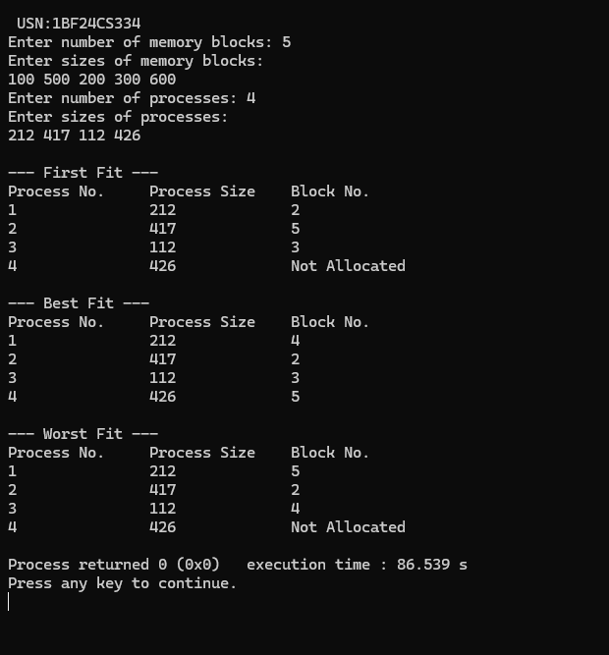

Program -7
Question:
Write a C program to simulate page replacement algorithms.
a) FIFO
b) LRU
c) Optimal

#include <stdio.h>
#include <limits.h>
void fifo(int pages[], int n, int num_frames) {
int frames[num_frames];
for (int i = 0; i < num_frames; i++) frames[i] = -1;
int page_faults = 0, next = 0;
printf("\nFIFO Page Replacement:\n");
for (int i = 0; i < n; i++) {
int page = pages[i], found = 0;
for (int j = 0; j < num_frames; j++) {
if (frames[j] == page) { found = 1; break; }
}
if (!found) {
page_faults++;
frames[next] = page;
next = (next + 1) % num_frames;
}
printf("Page %d: ", page);
for (int j = 0; j < num_frames; j++) printf("%d ", frames[j]);
printf("\n");
}
printf("Total Page Faults (FIFO): %d\n", page_faults);
}
void optimal(int pages[], int n, int num_frames) {
int frames[num_frames];
for (int i = 0; i < num_frames; i++) frames[i] = -1;
int page_faults = 0;
printf("\nOptimal Page Replacement:\n");
for (int i = 0; i < n; i++) {
int page = pages[i], found = 0;
for (int j = 0; j < num_frames; j++) {
if (frames[j] == page) { found = 1; break; }
}
if (!found) {
page_faults++;
int placed = 0;
for (int j = 0; j < num_frames; j++) {
if (frames[j] == -1) { frames[j] = page; placed = 1; break; }
}
if (!placed) {
int farthest = -1, replace_index = -1;
for (int j = 0; j < num_frames; j++) {
int next_use = INT_MAX;
for (int k = i + 1; k < n; k++) {
if (pages[k] == frames[j]) { next_use = k; break; }
}
if (next_use > farthest) {
farthest = next_use;
replace_index = j;
}
}
frames[replace_index] = page;
}
}
printf("Page %d: ", page);
for (int j = 0; j < num_frames; j++) printf("%d ", frames[j]);
printf("\n");
}
printf("Total Page Faults (Optimal): %d\n", page_faults);
}
void lru(int pages[], int n, int num_frames) {
int frames[num_frames], last_used[num_frames];
for (int i = 0; i < num_frames; i++) { frames[i] = -1; last_used[i] = -1; }
int page_faults = 0;
printf("\nLRU Page Replacement:\n");
for (int i = 0; i < n; i++) {
int page = pages[i], found = 0;
for (int j = 0; j < num_frames; j++) {
if (frames[j] == page) { found = 1; last_used[j] = i; break; }
}
if (!found) {
page_faults++;
int placed = 0;
for (int j = 0; j < num_frames; j++) {
if (frames[j] == -1) { frames[j] = page; last_used[j] = i; placed = 1; break; }
}
if (!placed) {
int lru_index = 0;
for (int j = 1; j < num_frames; j++) {
if (last_used[j] < last_used[lru_index]) lru_index = j;
}
frames[lru_index] = page;
last_used[lru_index] = i;
}
}
printf("Page %d: ", page);
for (int j = 0; j < num_frames; j++) printf("%d ", frames[j]);
printf("\n");
}
printf("Total Page Faults (LRU): %d\n", page_faults);
}
int main() {
int num_frames, n;
printf("Enter number of frames: ");
scanf("%d", &num_frames);
printf("Enter length of reference string: ");
scanf("%d", &n);
int pages[n];
printf("Enter the reference string (space-separated): ");
for (int i = 0; i < n; i++) {
scanf("%d", &pages[i]);
}
fifo(pages, n, num_frames);
optimal(pages, n, num_frames);
lru(pages, n, num_frames);
return 0;
}

Output>>>
